# CCET 3680 Mill Lesson 2 First Exercise

I. Wireframe:

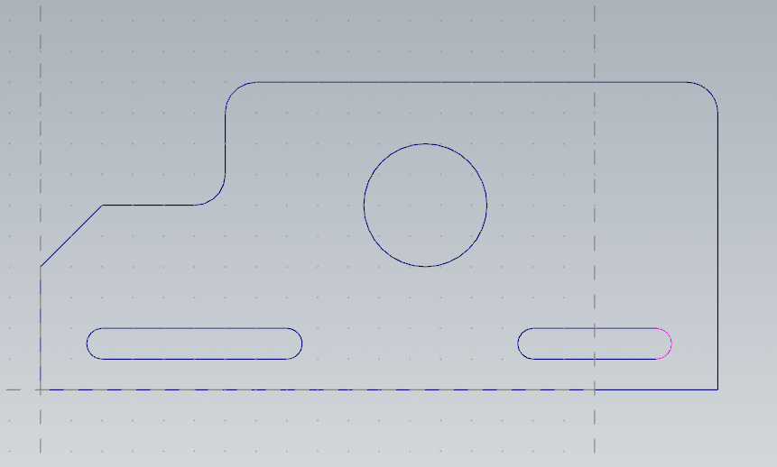

II. Dimensions:

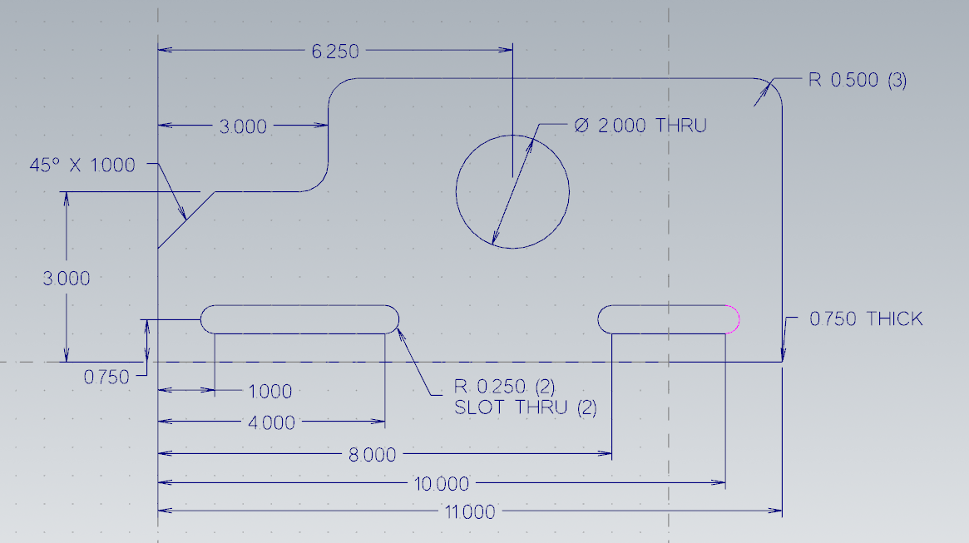

III. Solid:

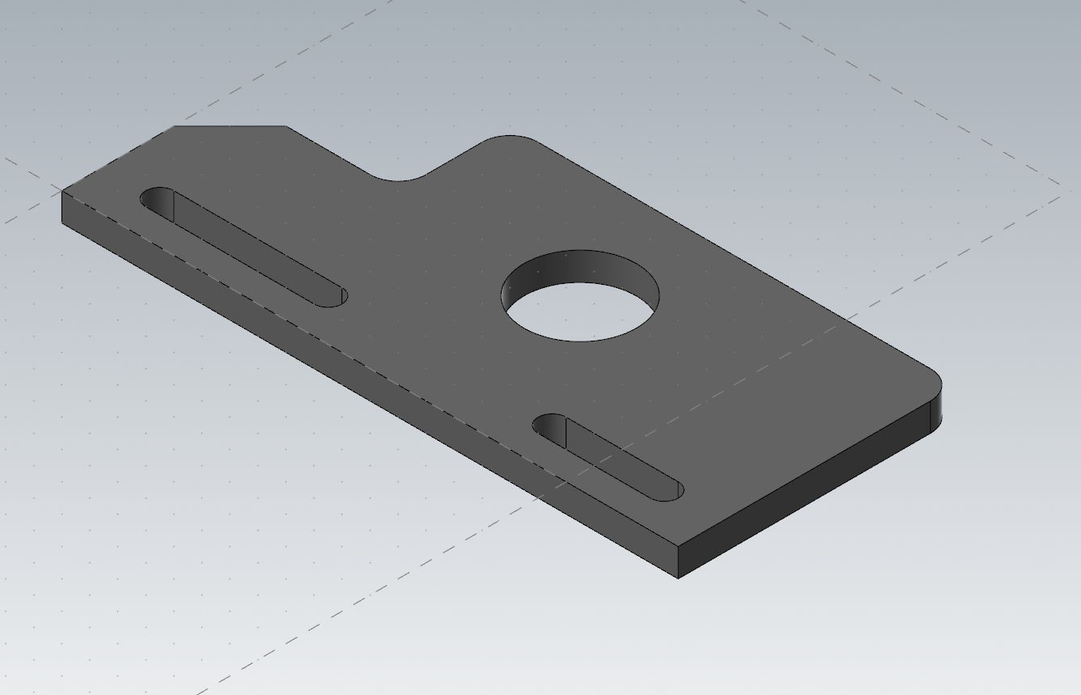

IV. Method:

First I drew the edges of the part with individual lines. Then I offset these to create the perimeter wireframe. After this I added the 3 fillets and the chamfer using the tools for each. After that I located the center of the hole by placing a point. I drew the two slots by offsetting a line from the base and then offsetting the radius of the slot to then draw a tangent arc for the slots. Then I just connected the lines and added the dimensions and solid.